
Final Lab Sessional
Computer Networks Lab_241L
UW-24-CS-BS-101
Registration NO:
Muhammad Talha_CS.3ndB
UNIVERSITY OF WAH(UOW)

DEPARTMENT OF COMPUTER
SCIENCE

COURSE:

SUBMITTED TO:

Mr. Hassan Shafaqat
SUBMITTED BY:

Task 2
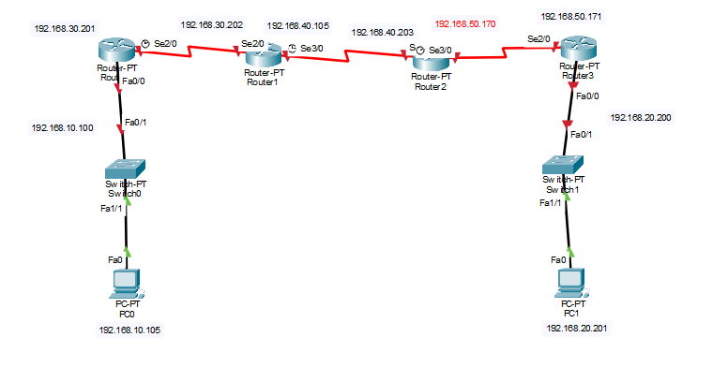
Router 1
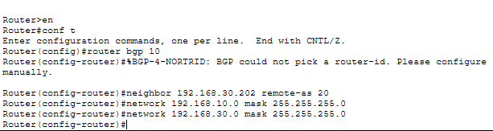
Router 2
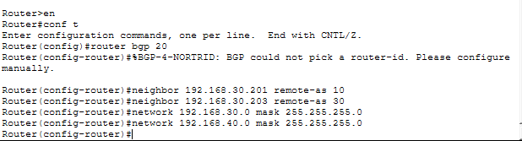
Router 3
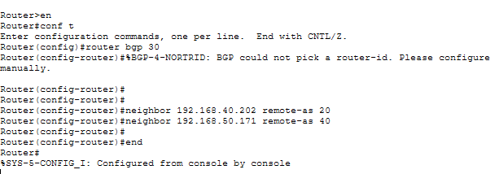
Router 4
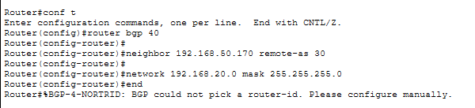
Check Messaging
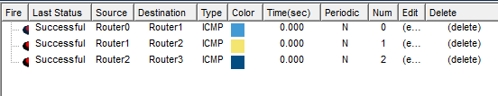

Task 3
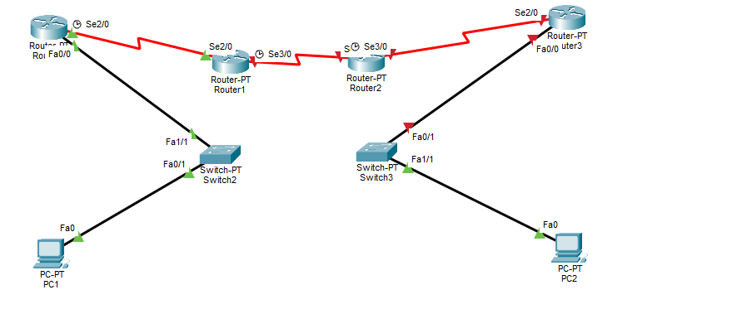
Every Router
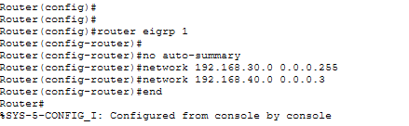
Sending
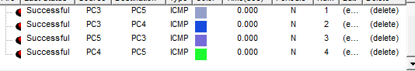

Task 1
Task 01:
A family home has multiple smartphones and laptops that need secure wireless access while a desktop computer is connected via cable; DESIGN a wireless network using 2 wireless router, 3 wireless devices, and 1 wired PC, configure wireless security and IP addressing, and confirm that all devices can communicate successfully within the network
Solution:
Step 01:
Add two wireless routers in the network and also add one switch and also add three devices three are wireless and one pcs are connected via cable:
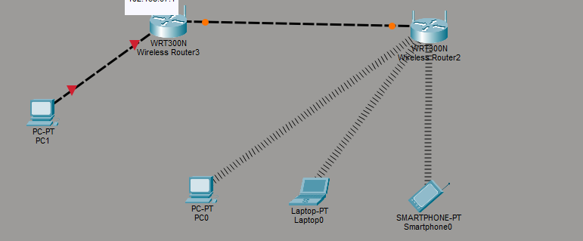
Step 02:
Give Ip Addresses according to the instructions:
Router 01:
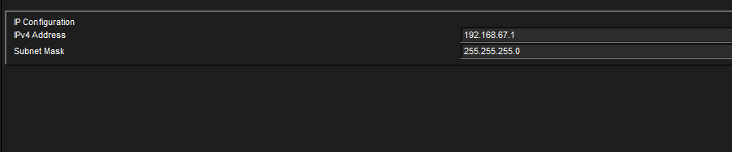
PC 01 connected via cable
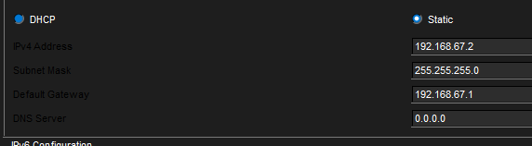

Wireless pcs and laptops and msart phone:
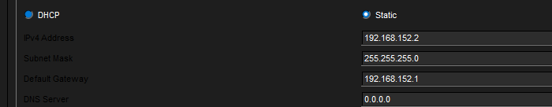

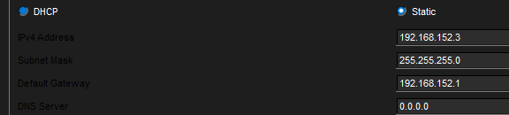
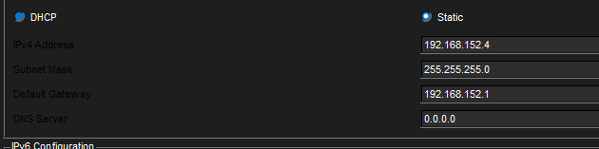
Step 03:
Send messages:
